We Utilize 8 API’s

**1.addplayers**

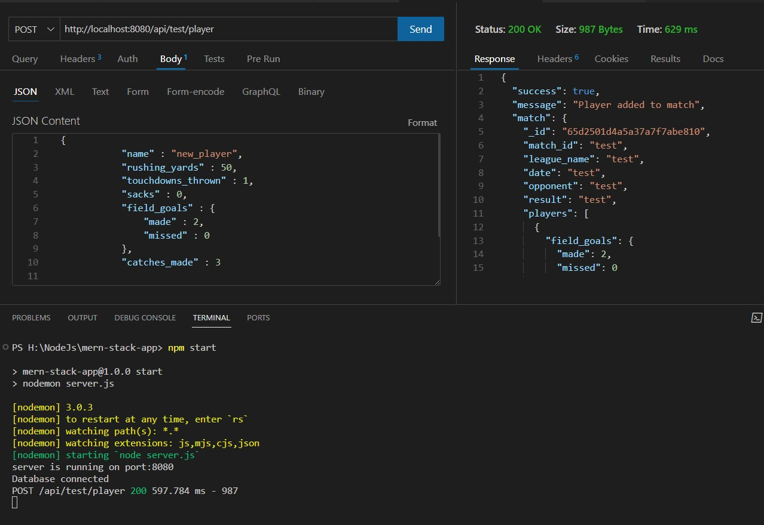

* Addplayers is use to add players.
* I am organizing a match and I will be adding another player.

**2.Updateplayers**

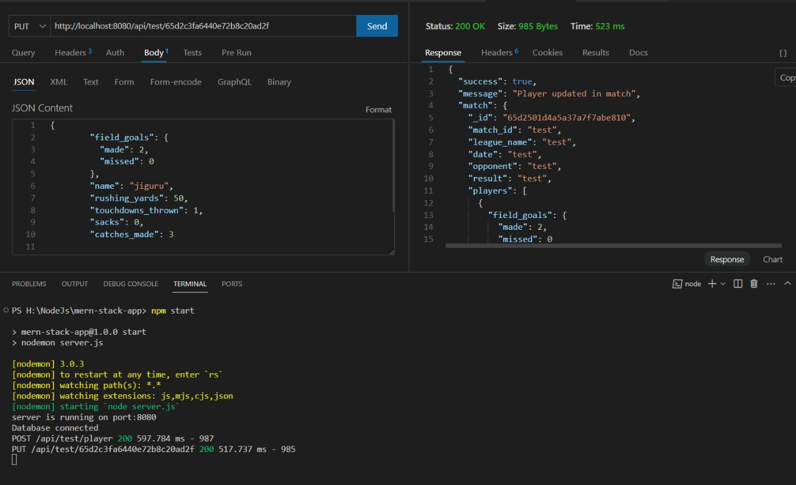

* Second updateplayers which is use to update the update the players data ...

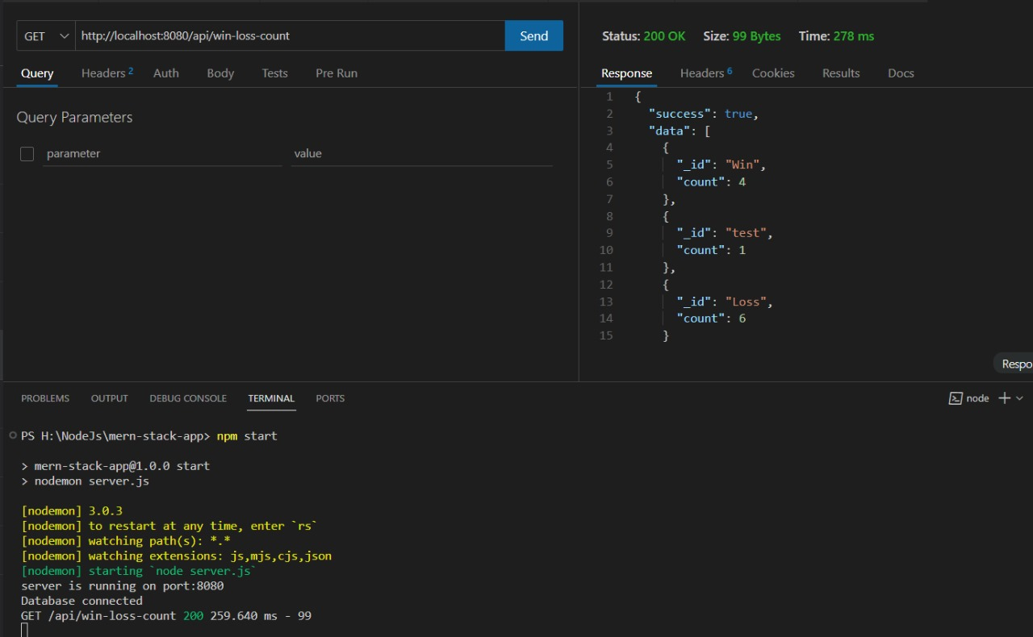3.**getWinLossCount**

* getWinLossCount
* retrive the date to get the count

**4.delete player**

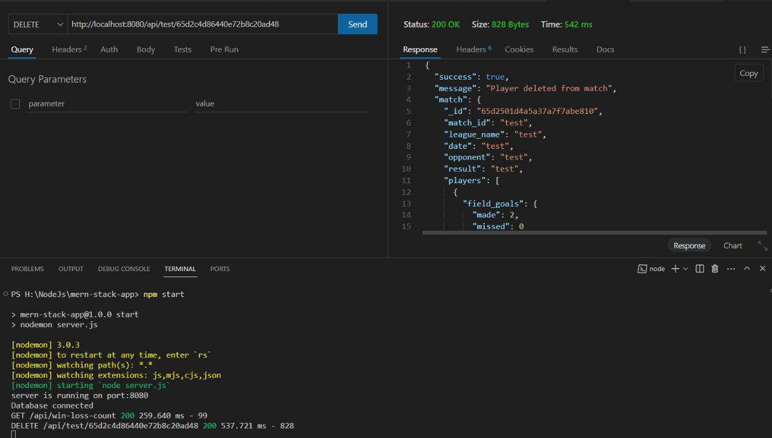

* deleted players which is used to delete players, and also which is used to delete some particular data

**5.retrieving the data to getTopSackPlayers using get request**

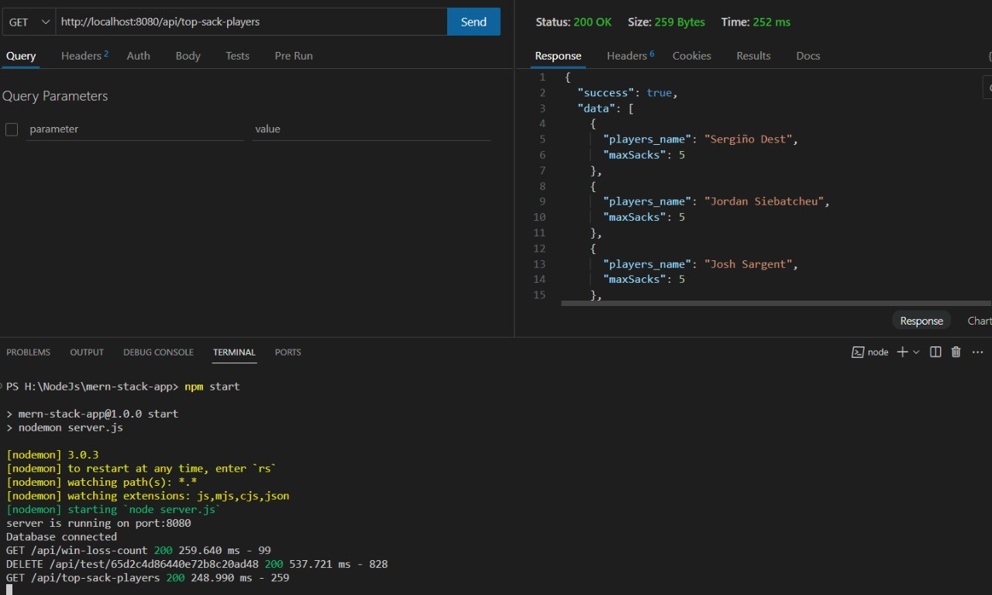

* retrieve the data to getaTopSackPlayers using request ,which is used to requesting the data from getTopSackPlayers

**6.retrieving the data to get players-by-field-goals-made using get request**

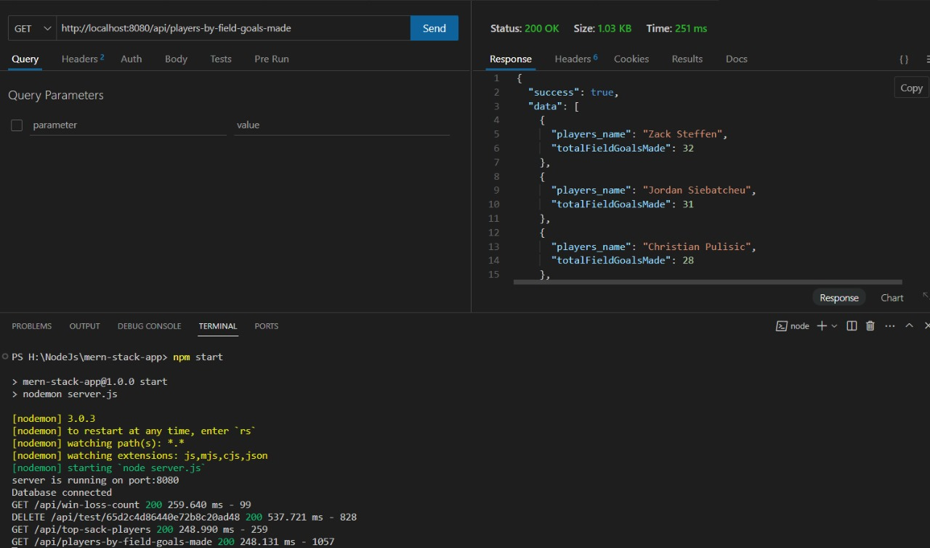

* retrieving the data to get players-by-field-goals-made using get request

**7.retrieve the data to getTotalRushingYardsForMatch using post request**

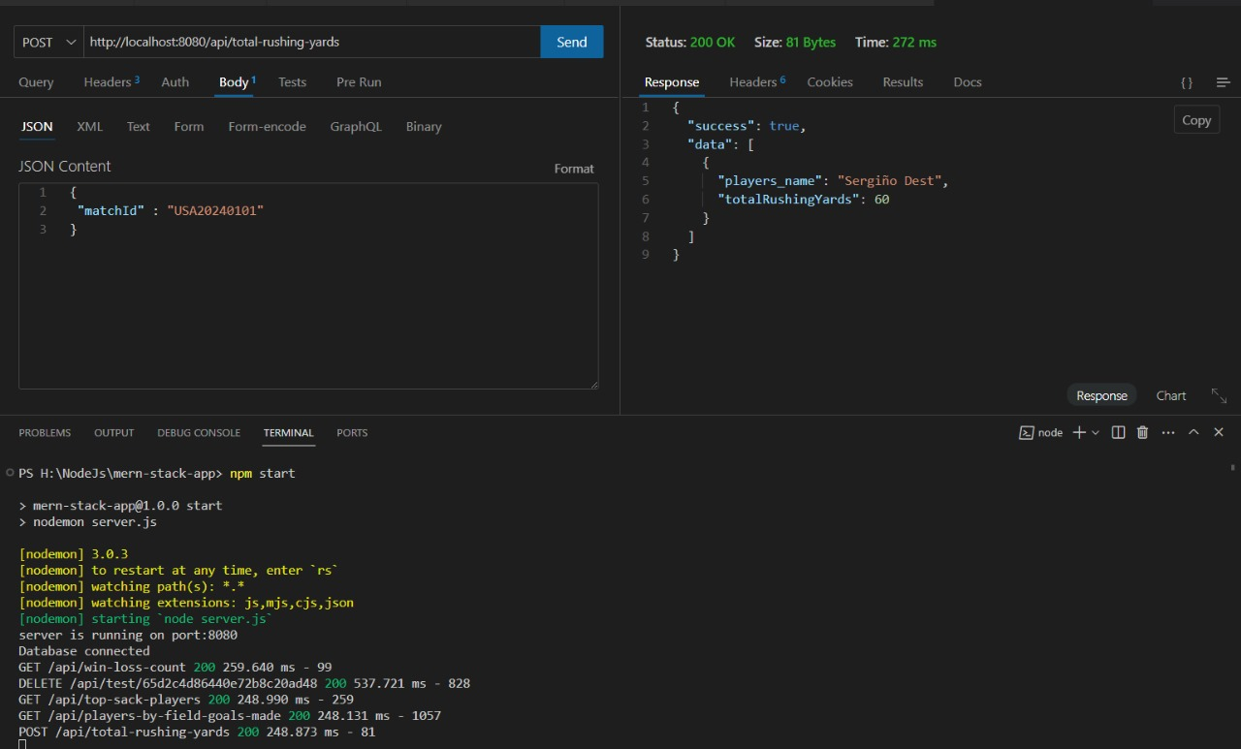

* retrieve the data to getTotalRushingYardsForMatch using post request

**8.retrieve the data to get average-rushing-yards**

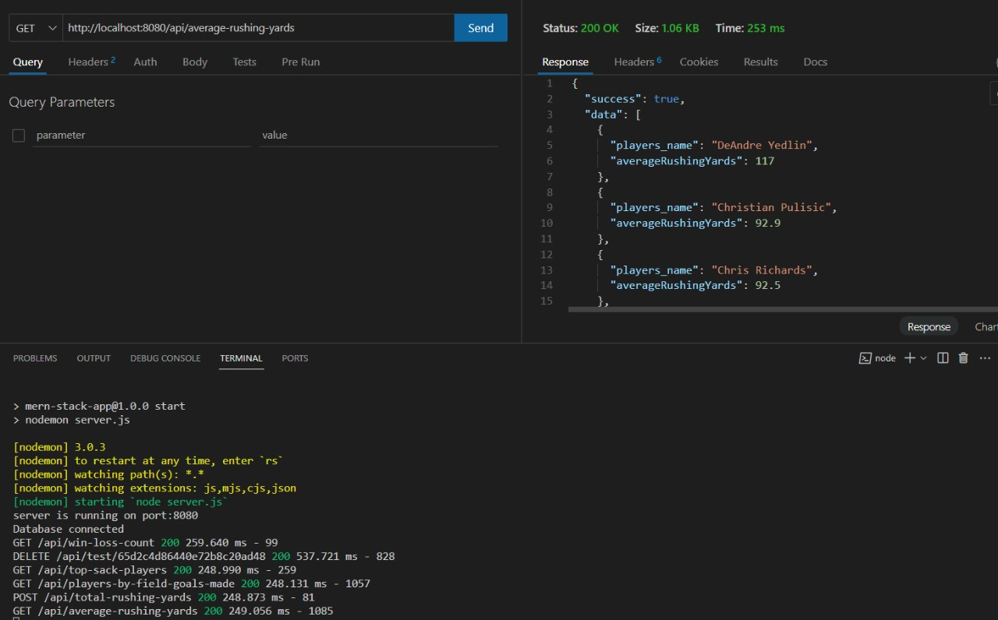

* retrieve the data to get average-rushing-yards

I believe that my dedication and hard work warrant an A+ grade.

Regarding the solution, I encountered challenges during the data insertion process, particularly in collecting information about the players. Despite these obstacles, I persevered and managed to complete the task to the best of my ability. During the data inserting I feel little bit critical and collecting of data of the players.